Chapter 7 Exercises
To test whether a table has been modified correctly as you do these exercises, you can write and run an appropriate SELECT statement. Or, when you’re using Oracle SQL Developer, you can click on a table name in the Connections window and then on the Data tab to display the data for all of the columns in the table. To refresh the data on this tab, click the Refresh button.
- Write an INSERT statement that adds this row to the Invoices table:
invoice_id The next id in sequence (find out what this should be)
vendor_id: 32
invoice_number: AX-014-027
invoice_date: 8/1/2008
invoice_total: $434.58
payment_total: $0.00
credit_total: $0.00
terms_id: 2
invoice_due_date: 8/31/2008
payment_date: null
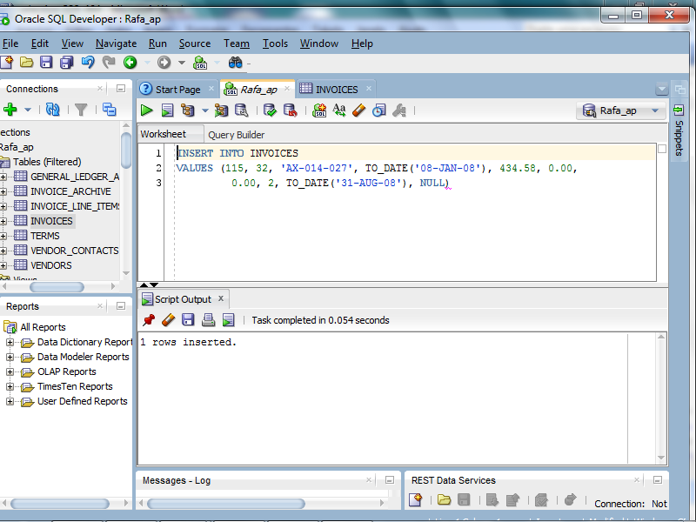
- Write an UPDATE statement that modifies the Vendors table. Change the default account number to 403 for each vendor that has a default account number of 400.
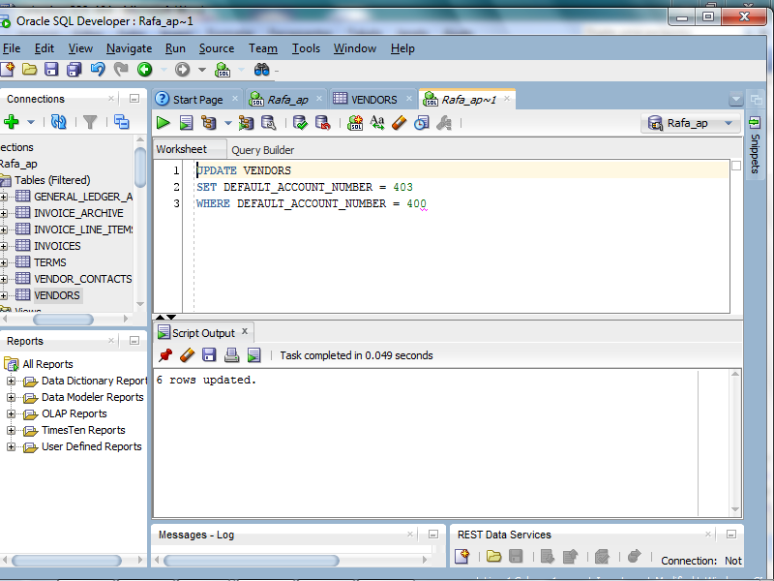
- Write an UPDATE statement that modifies the Invoices table. Change the terms_id to 2 for each invoice that’s for a vendor with a default_terms_id of 2.
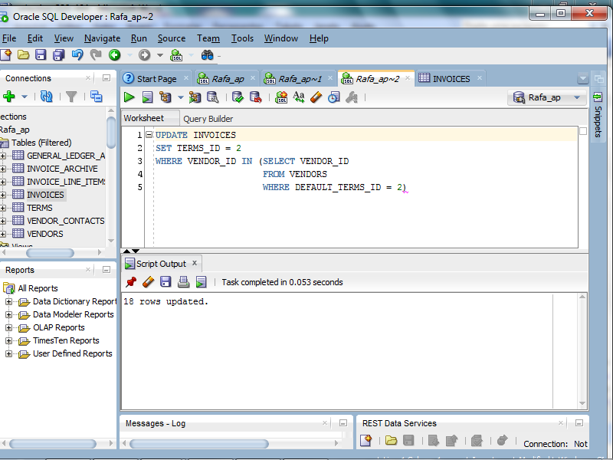
- Write a DELETE statement that deletes the row that you added to the Invoices table in exercise 1.
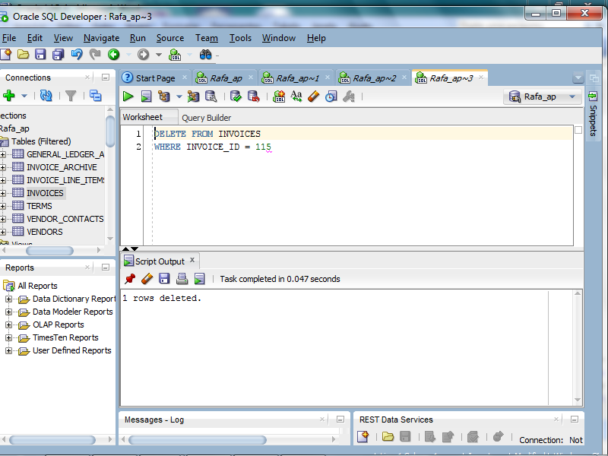
- After you have verified that all of the modifications for the first four exercises have been successful, rollback the changes. Then, verify that they have been rolled back.
1
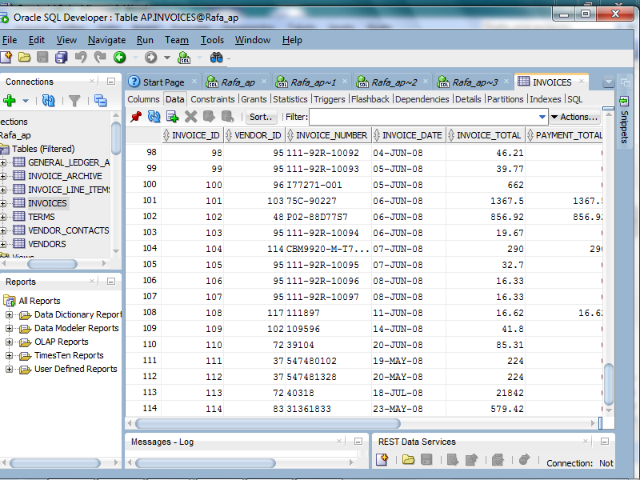

2
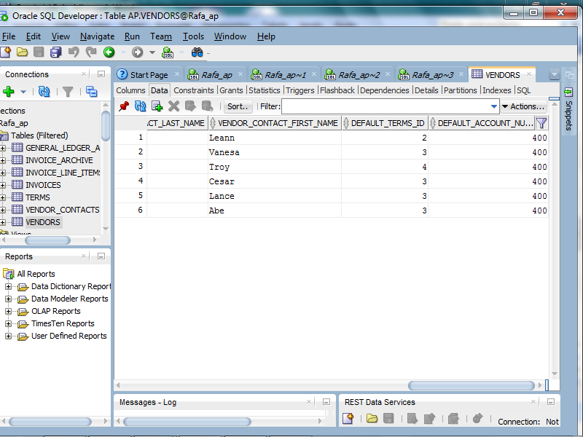
3
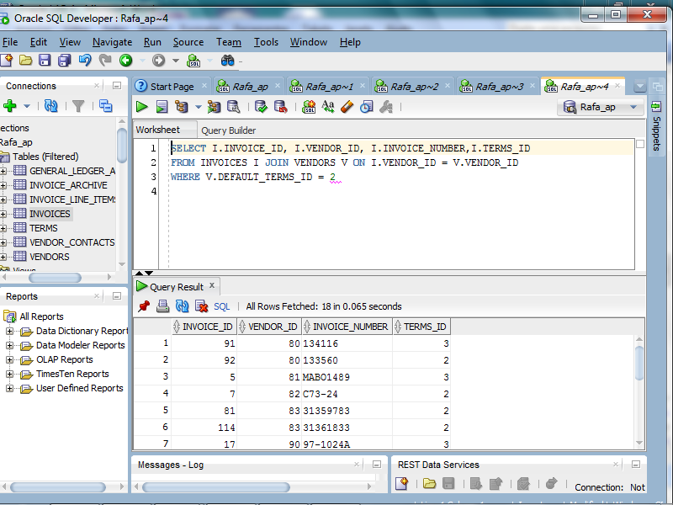
4
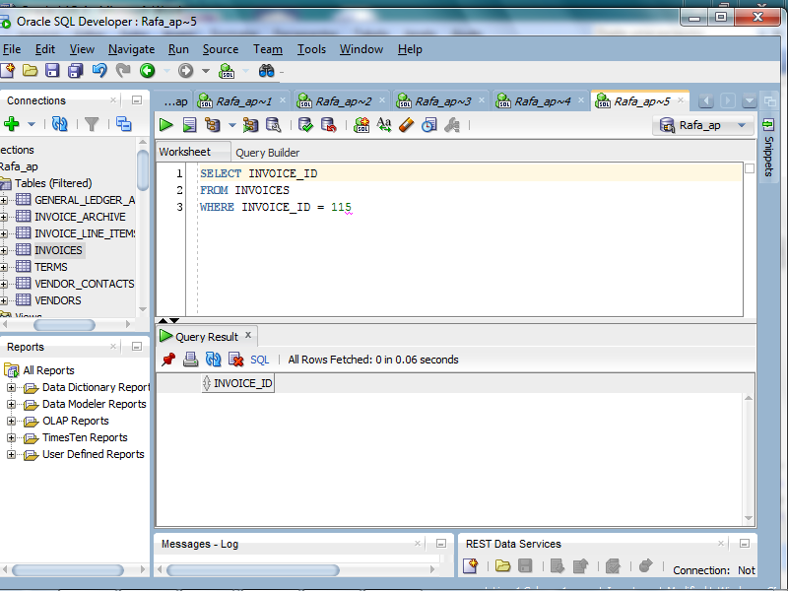

Chapter 8 Exercises
- Write a SELECT statement that returns these columns from the Invoices table:
The invoice_total column
Use the TO_CHAR function to return the invoice_total column with 2 digits to the right of the decimal point.
Use the TO_CHAR function to return the invoice_total column with no digits to the right of the decimal point and no decimal point
Use the CAST function to return the invoice_total column as an integer with seven digits
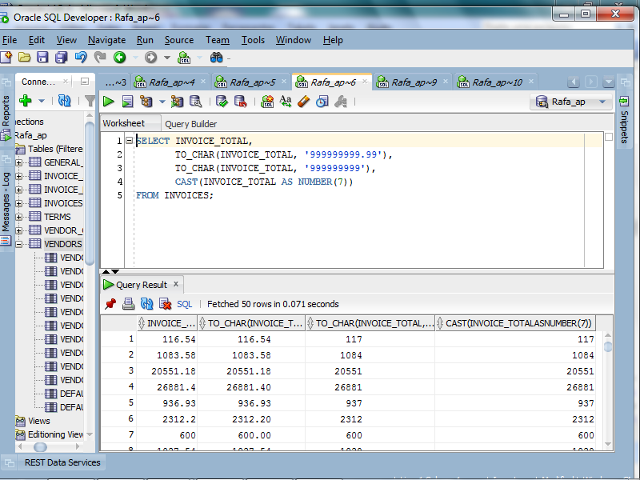
- Write a SELECT statement that returns these columns from the Invoices table:
The invoice_date column
Use the TO_CHAR function to return the invoice_date column with its full date and time including a four-digit year on a 24-hour clock
Use the TO_CHAR function to return the invoice_date column with its full date and time including a four-digit year on a 12-hour clock with an am/pm indicator
Use the CAST function to return the invoice_date column as VARCHAR2(10)
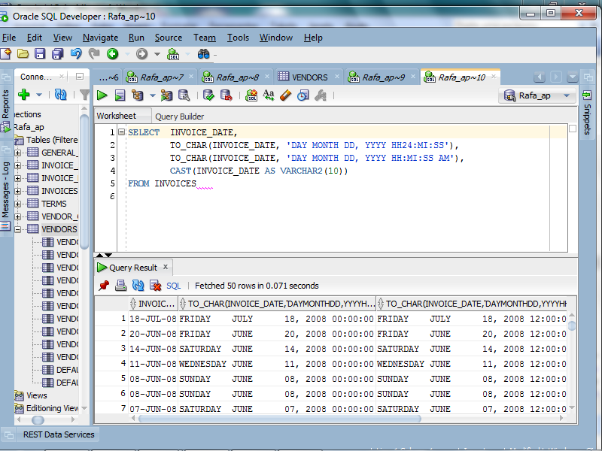

- Write a SELECT statement that returns these columns from the Vendors table:
The vendor_name column
The vendor_name column in all capital letters
The vendor_phone column
The last four digits of each phone number
When you get that working right, add the columns that follow to the result set. This is more difficult because these columns require the use of functions within functions.
The second word in each vendor name if there is one; otherwise, blanks
The vendor_phone column with the parts of the number separated by dots as in 555.555.5555
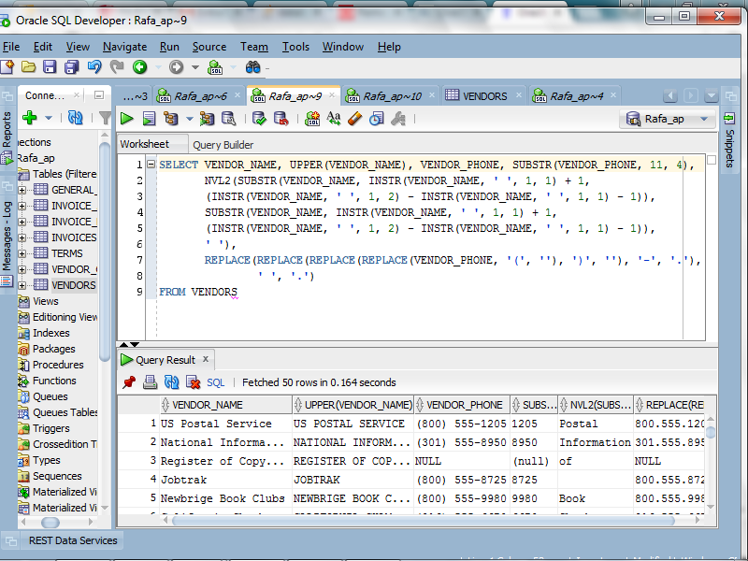

- Write a SELECT statement that returns these columns from the Invoices table:
The invoice_number column
The invoice_date column
The invoice_date column plus 30 days
The payment_date column
A column named days_to_pay that shows the number of days between the invoice date and the payment date
The number of the invoice_date’s month
The four-digit year of the invoice_date
The last day of the invoice date’s month
When you’ve got this working, add a WHERE clause that retrieves just the invoices for the month of May based on the invoice date, not the number of the invoice month.
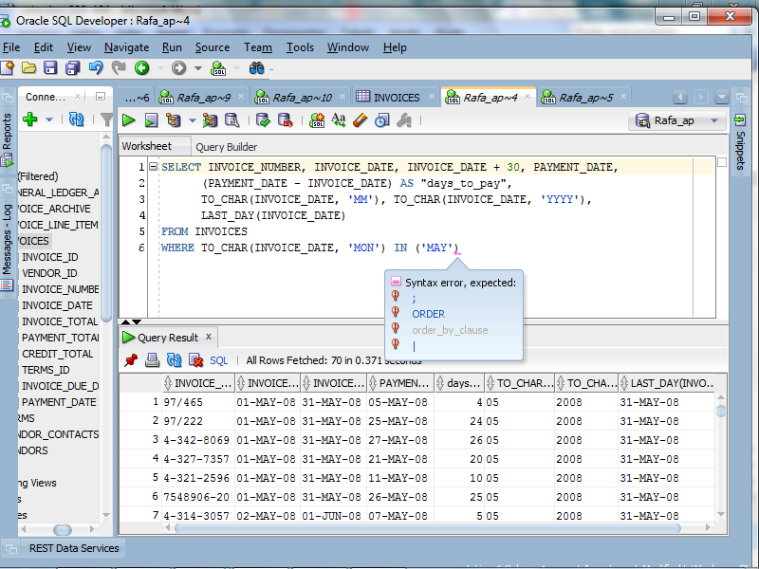

- Write a SELECT statement that returns these columns from the Invoices table:
The invoice_number column
The balance due (invoice total minus payment total minus credit total) with commas, a decimal point, and two decimal positions
A column named “Balance Rank” that uses the RANK function to return a column that ranks the balance due in descending order.
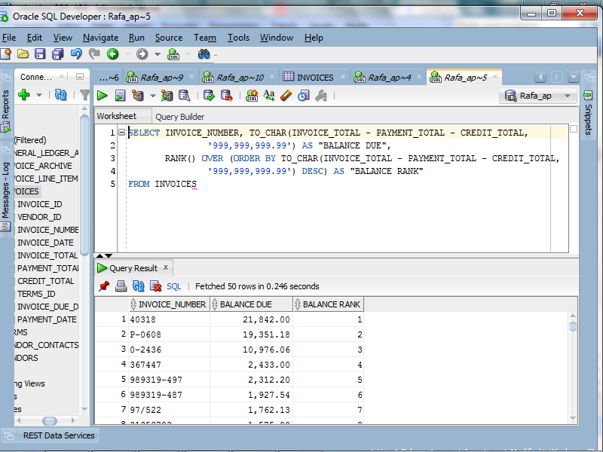

Chapter 9 Exercises
Design a database for tracking memberships
- Draw a database diagram for a database that tracks the memberships for an association and for the groups within the association. Assume that each member can belong to any number of groups and that each group can have any number of members.
- Modify your design for exercise 2 to keep track of the role served by each individual in each group. Assume that each individual can only serve one role within a group and that each group has its own set of roles that members can fulfill.

NOTE: Chapter 9 Exercises are optional since database design is covered in IS:225.

